**Showcase your work**

Congratulations on earning your Google Cybersecurity Certificate! Now it’s time to let the world know about the skills you’ve gained to help advance your career. We recommend adding the completion of this certificate program to your resume and LinkedIn® profile.  Read on and follow these tips to get started.

**Add the Google Cybersecurity Certificate to your resume and LinkedIn® profile**

You may have already started on a cybersecurity resume earlier in the program. If not, there are a variety of digital templates for creating your resume available at [Enhancv](https://app.enhancv.com/industry-examples), [Big Interview](https://googlecerts.biginterview.com/), [Google Docs](https://docs.google.com/document/u/0/?ftv=1&tgif=c), or [Microsoft Word](https://templates.office.com/). You can find additional resume creation guidance in this lesson from Google Applied Digital Skills: [Start a Resume](https://applieddigitalskills.withgoogle.com/c/college-and-continuing-education/en/start-a-resume/overview.html).

**Update your Education or Licenses and Certifications section**

* To add the completion of this certificate to your resume, update your ***Education*** or ***Licenses & Certifications*** section.
* To add the completion of this certificate to the ***Licenses & Certifications*** section of your LinkedIn profile, follow the [steps listed in this LinkedIn® Help article](https://www.linkedin.com/help/linkedin/answer/44644).

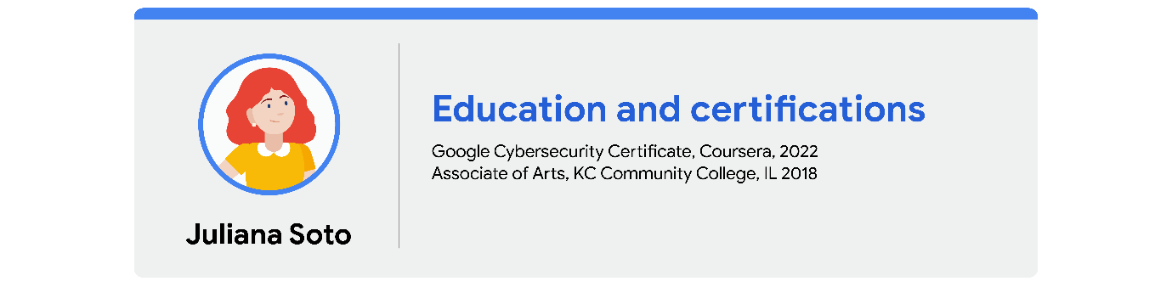

**Update your Skills section**

* If applicable, update the ***Skills*** section of your resume. Following is a comprehensive list of skills that this certificate was designed to help you develop that you could potentially add.
* To update the ***Skills & Endorsements*** section of your LinkedIn® profile, follow the [steps listed in this LinkedIn® Help article.](https://www.linkedin.com/help/linkedin/answer/4976)

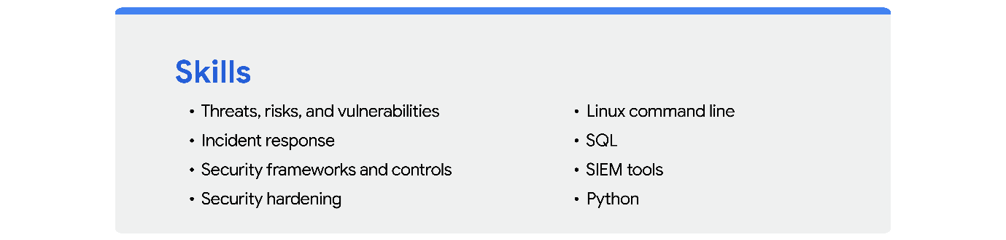

**Update your Summary or About section**

* If your resume has a ***Summary*** section, you can include this certification as a qualification.
* To include a summary that mentions this certification in your LinkedIn® profile, update your ***About*** section by following the [steps listed in this LinkedIn® Help article](https://www.linkedin.com/help/linkedin/answer/92157).

Here is an example of a professional summary:

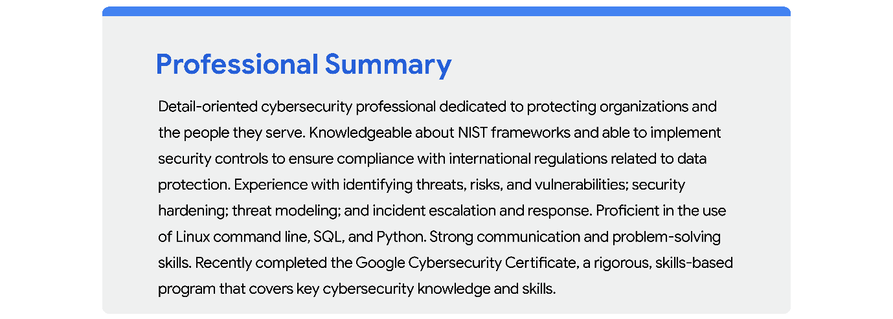

**Add your badge**

Check out the next course item to learn how to claim your Google Cybersecurity Certificate completion badge and add it to your LinkedIn® profile!